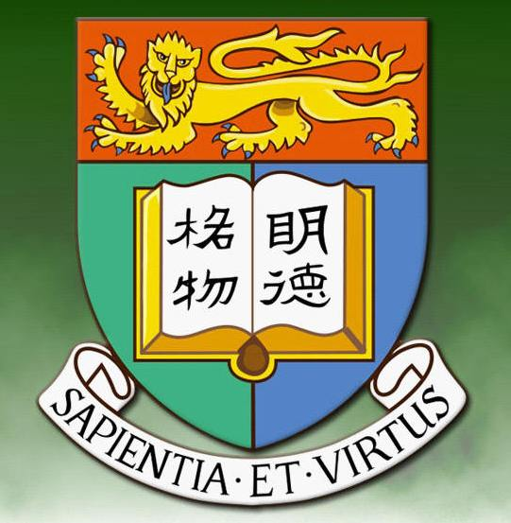
2007 Spring Gathering Report

By Sau-Fong Siu

The HKU Alumni Network of New England held a luncheon on 5th May 2007 in Yangtze River Restaurant, Lexington, Massachusetts. It was attended by 22 adults and 4 children. Alumni who were present included those who graduated from the 1960s (Stephen Louie 雷惠英, Connie Louie 雷楊國莉, Yum-Tong Siu 蕭蔭堂, Sau-Fong Siu蕭黃秀芳, Son-Mey Chiu 趙洵美, and Benjamin Hui 許清如), from the 1970s (Chi-Sang Poon潘志生, Dominic Foo 傅錦蘇, Vivienne Hsu 許龍綺玲, and Chau-Ming Lee 李秋明) , from the 1980s (Keung Chi Ng 吳強枝), from the 1990s (Rita Tsang 曾超慧, Albert Kong 江國興and Michael Koon 管漢偉) and from the 2000s (Jie Hu 胡潔and Denvid Lau 劉特斌). The group will meet again in the fall of 2007. Alumni relocating to Massachusetts and other states in New England are urged to contact the facilitators of the alumni network 蕭蔭堂 (siu@math.harvard.edu) or 蕭黃秀芳 (ssiu@wheelock.edu)

